ADVANCED SYNOPTIC METEOROLOGY
METR 5413
Howie “Cb” Bluestein

Problem Set #2
Handed out: Tuesday, 4 Feb. 2020
Due: Thursday, 13 Feb. 2020

In Vol. I: Problems 5.13, 5.16, 5.18, 5.26, 5.28, and 5.37:

1. Consider the height contours (solid lines, dam) and isotherms (dashed lines, ⁰C) at 850 hPa sketched below. You may neglect the β effect.
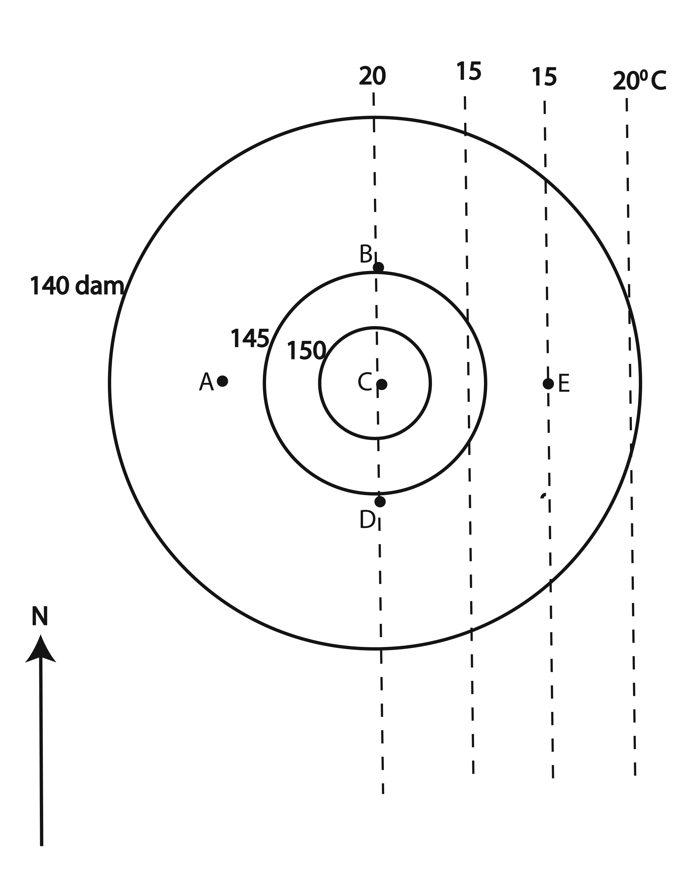

Use the Trenberth formulation of the quasigeostrophic ω equation to make a qualitative sketch of the ω field at 850 hPa (where is ω>0, <0?). Be sure to show your reasoning. You may assume that the isotherms at 850 hPa are representative of the mean isotherms in a layer centered at 850 hPa. Neglect friction and diabatic heating.

