Problem Set #1

Advanced Mesoscale Meteorology
METR 6413, Sec. 1
Howie “Cb” Bluestein

Handed out: Thurs., 27 Aug. 2020

Due: Tues, 8 Sept. 2020

1. Consider the vertical cross section of m_{g} (solid lines; m s⁻¹) and equivalent potential temperature (dashed lines; K) shown below:
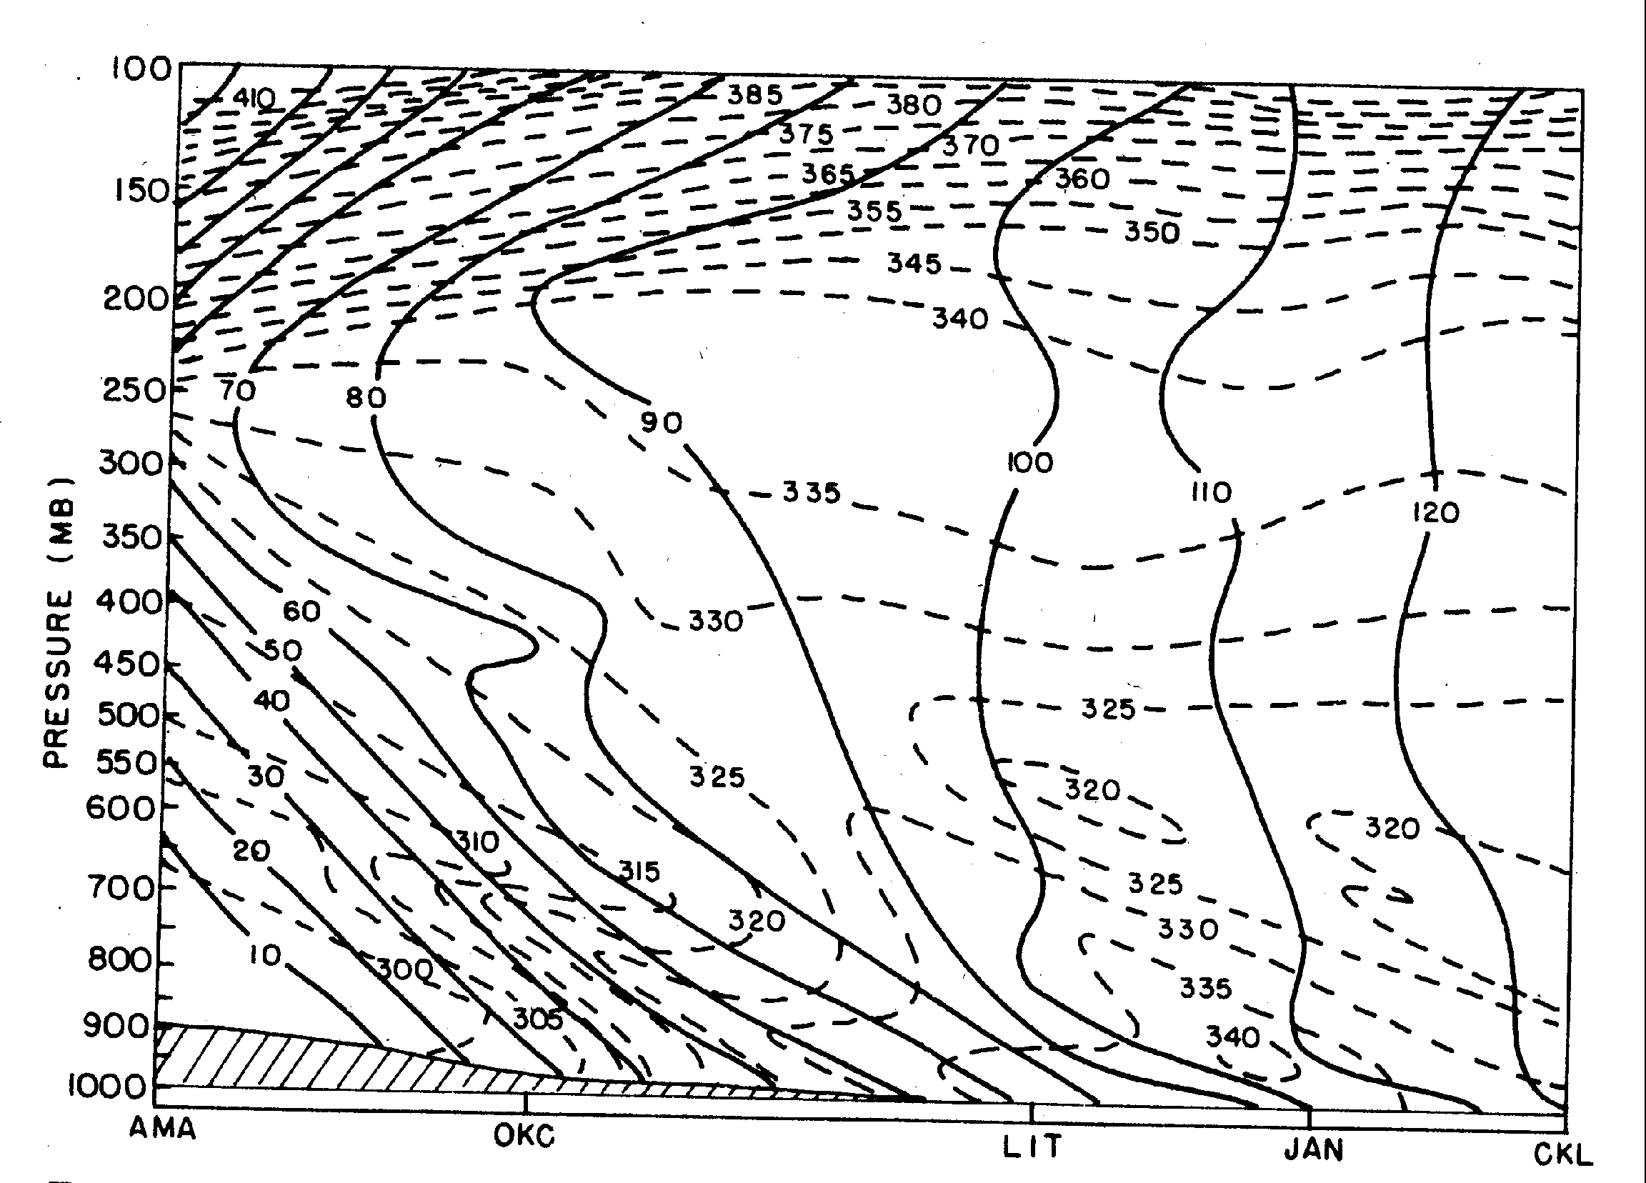
Make a plot of a sounding (temperature and dew point vs. pressure on a skew T – log p diagram) along the m_{g} = 70 m s⁻¹ surface, which passes near the ground level at Little Rock, AR (LIT). Is the sounding along this m_{g} surface conditionally unstable anywhere? (In other words, is the sounding conditionally symmetrically unstable?) Compare it to the regular sounding at LIT. Feel free to interpolate equivalent potential temperature by eye to get temperature and dewpoint. Assume that the air is saturated everywhere below 700 mb, and neglect moisture above 700 hPa.

2. Consider a material tube (a symmetric air parcel extending infinitely off in the ± x direction) that is displaced upward and to the north (+y direction) slightly (just 100 km to the north) of its original position so that it becomes embedded in an environment of u_{g} = 15 m s⁻¹ at 36⁰ N.

(a) If it originally was moving in the +x direction at 18 m s⁻¹ and let go, what is its acceleration in the y direction? Neglect friction and assume that the movement of the tube does not disturb the environmental pressure field.

(b) If ∂m_{g}/∂y is constant and < 0 in the environment, what is the period of oscillation of the tube in the y direction?

